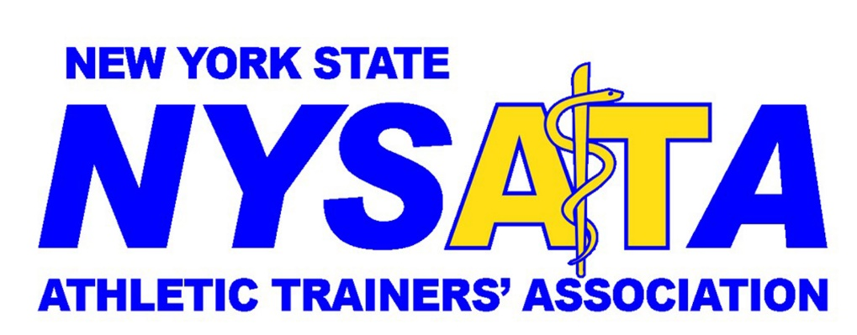
Photo Release Form
New York State Athletic Trainers’ Association
Permission to use photograph
I grant to the NYSATA, the right to take photographs of me. I authorize NYSATA, its assigns and transferees to copyright, use and publish the same in print and / or electronically.
I agree that NYSATA may use such photographs of me with or without my name and for any lawful purpose, including for example such purposes as publicity, illustration, advertising and web content.
I have read and understand the above.
Signature _________________________________
Printed name ______________________________
Signature, parent or guardian ______________________________
(If photo subject is under 18 years of age)
Printed name ______________________________
Address __________________________________
Date _____________________________________
Email completed form to: webmaster@gonysata2.org

