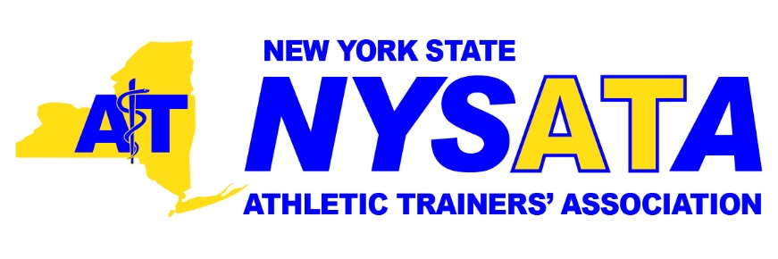
Leadership vacancies - Summer 2019

Regional Representatives:

Region 4 – counties represented: Lewis, St. Lawrence, Jefferson, Franklin, Clinton, Essex, Warren and Hamilton.

Region 5 – counties represented: Chemung, Tioga, Broome, Oswego, Cayuga, Seneca, Cortland, Chenango, Onondaga, Tompkins, Schuyler, Oneida and Madison

Region 6 – counties represented: Livingston, Ontario, Monroe, Steuben, Yates and Wayne

Eligibility: nominee must be a member in good standing and live in one of the region’s represented counties.
Duties:
- To serve as members of the Executive Council.
- To act as liaison between region members and the Executive Council.
- To solicit information from regional membership for the NYSATA Newsletter.
- To implement the policies and actions of the Executive Council within their regions.
- To serve on the Membership and Nominating Committee along with the NYSATA Secretary.
- Annually attend one (1) meeting of the Executive Council.
- Term of office shall be two (2) years. The Regional Representative will be voted in by regional membership. May be re-appointed with Executive Council approval.

Committee Chairpersons:

College/University Committee
Eligibility: nominee must be a member in good standing.
Duties:
- Represent college/university athletic trainers in New York State.
- Monitor District and National trends in this setting, in coordination with the NATA College and University Athletic Trainers’ Committee [now the Intercollegiate Council on Sports Medicine].
- Report the current issues and trends in college/universities to the Executive Council and membership.
- Provide input to the Executive Council.
- Annually attend one (1) meeting of the Executive Council.
- Term of office shall be two (2) years and may be-reappointed with Executive Council approval.

History/Archives Committee
Eligibility: nominee must be a member in good standing.
Duties:
- Compiles a history of the New York State Athletic Trainers’ Association, Inc.
- Establishes a plan for the maintenance of the historical records of the NYSATA, Inc. and for preserving important archives.

Membership/Nominations Committee
Eligibility: nominee must be a member in good standing.
Duties:
- Seek qualified candidates for each of the elected offices in the NYSATA, Inc.
- Conducts an election of officers from those names on the candidate list and those nominated from the floor during the course of the annual business meeting. This election shall be by written secret ballot or electronic means.
- Conducts a regional election of Regional Representatives from those names on the candidate list and those nominated from the floor during the course of the annual business meeting. This election shall be by written secret ballot or electronic means.
- Receives and reviews all proposals for the initiation of new or additional honor awards and makes recommendations to the Executive Council.
- Annually attend one (1) meeting of the Executive Council.
- Term of office shall be two (2) years and may be re-appointed with Executive Council approval.

Public Relations Committee Co-Chair
Eligibility: nominee must be a member in good standing.
Duties:
- Establish and maintain an effective public relations program for the NYSATA, Inc. in coordination with the Executive Council, Newsletter Editor and NYSATA Webmaster.
- Investigate and recommend to the Executive Council possible avenues through which the NYSATA, Inc. may enhance its professional image and interpret the NYSATA, Inc. purposes and objectives to allied associations, high schools, colleges and the general public.
- Make recommendations to the Executive Council regarding advantageous professional affiliations and liaison activities.
- Monitor District and National trends and efforts, in coordination with the NATA Public Relations Committee.
- Annually attend one (1) meeting of the Executive Council.
- Term of office shall be two (2) years and may be re-appointed with Executive Council approval.

Research Committee
Eligibility: nominee must be a member is good standing.
Duties:
- Maintain an up to date list of federal and state sources of funding for research in the field of sports medicine.
- Investigate, recommend and promote research by NYSATA, Inc. members.
- Seek out, evaluate, and approve poster presentations for annual NYSATA Conference.
- Monitor District and National trends and efforts, in coordination with the NATA Research and Education Foundation.
- Annually attend one (1) meeting of the Executive Council.
- Term of office shall be two (2) years and may be re-appointed with Executive Council approval.

Young Professional Committee – District 2 New York State Representative
Eligibility: nominee must be a member in good standing and be within their initial 12-years as a BOC Athletic Trainer, but not over 9-years certified at the date of appointment.
Duties:
- Work with the District 2 Young Professionals Chair in furthering the goals of the NATA and District Young Professionals Committee
- Identify the needs and goals of Young Professionals in the state.
- Maintain regular communication and a working relationship with Young Professionals Committee District 2 Chair and the state Executive Council.
- Distribute District Young Professional Committee minutes, news, and updates to the state members.
- Serve as a member of a working group that includes other District 2 state representatives.
- Solicit new young professional athletic trainers in the state to join the Young Professional Committee and encourage current Young Professional members to remain active.
- Responsible for promoting the Young Professional Committee goals and ideas to state institutions, clinics, student programs and professional settings.
- Develop, implement and forecast projects designed for Young Professionals.
- Attend the District 2 Annual Meeting and State Annual meeting as available.
- Perform duties as assigned by the District 2 Young Professional Committee Chair.
- Present a report to the state members in attendance at the state meetings as applicable.
- Serve as an advisor or co-sponsor with other committees within the state
- Perform duties as assigned by the state president.
- Term of service is one year, two times renewable (for a total of 3-years duration possible service).

